**Introduction:**

This report presents a detailed Exploratory Data Analysis (EDA) and Descriptive Statistical insights derived from machine downtime data. The primary goal is to understand the behaviour of various machine parameters under different conditions, particularly when a machine experiences failure versus when it functions normally.

**Overall Design Strategy:**

The analysis was structured into four major phases:

1. **First Movement - Descriptive Central Tendency Analysis:**
   * Computation of mean, median, and mode to understand the centre of the data distribution.
2. **Second Movement - Variability Analysis:**
   * Assessment of standard deviation, variance, and range to measure spread and dispersion.
3. **Third Movement - Distribution Visualization:**
   * Histogram plots to examine the distribution pattern of each equipment parameter.
4. **Fourth Movement - Higher-Order Statistics:**
   * Kurtosis measurement to assess the tailedness of each distribution.

Further, a comparative analysis of machine condition under failure vs. non-failure was done across **mean, median, and max** values.

**Data Overview:**

* The dataset was cleaned by removing missing values.
* It contains 16 columns and multiple rows of time-series based machine data.
* Each row represents a machine's performance reading at a given time.

**Dataset Columns:**

1. **Date_Time** – Timestamp of the recorded data
2. **Machine_ID** – Identifier for the machine
3. **Assembly_Line_No** – Assembly line number
4. **Hydraulic_Pressure_bar** – Pressure in the hydraulic system
5. **Coolant_Pressure_bar** – Pressure in the coolant system
6. **Air_System_Pressure_bar** – Air pressure in the system
7. **Coolant_Temperature** – Temperature of the coolant
8. **Hydraulic_Oil_Temperature** – Temperature of the hydraulic oil
9. **Spindle_Bearing_Temperature** – Temperature of spindle bearing
10. **Spindle_Vibration** – Vibration magnitude at the spindle
11. **Tool_Vibration** – Vibration magnitude at the tool
12. **Spindle_Speed_RPM** – Rotational speed of the spindle
13. **Voltage_volts** – Voltage reading in volts
14. **Torque_Nm** – Torque in Newton-meters
15. **Cutting_kN** – Cutting force in kilonewtons
16. **Downtime** – Categorical column indicating "Machine_Failure" or "No_Machine_Failure"

The **Spindle_Speed_RPM** column was dropped because it contained outlier data which could distort the visualization and interpretation of other attributes. Additionally, Spindle_Speed_RPM analysis for both machine failure and non-failure conditions was conducted separately in sql.

**Summary Statistics:**

* **Mean** and **Median** were computed separately for Machine_Failure and No_Machine_Failure scenarios.
* The **difference** between them helped identify which features tend to increase or decrease during failure.
* **Histograms** provided an overview of distribution shapes for all operational parameters.
* **Kurtosis** indicated the presence of outliers or sharp peaks in distribution.

**Key Findings:**

* Several parameters showed **consistent increases or decreases** in value when the machine experienced downtime.
* These findings were visualized using bar charts, separately highlighting:
  + Good vs. Bad Machine Condition
  + Mean/Median/Max values
  + Parameters that increase or decrease during failure

**Common Attribute Change Summary:**

* **Consistently Increased Parameters During Failure:**

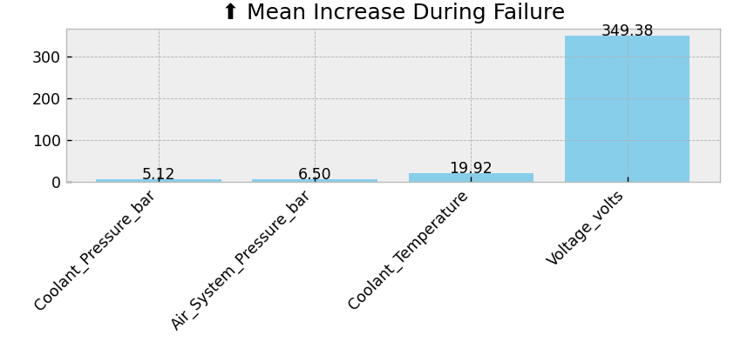

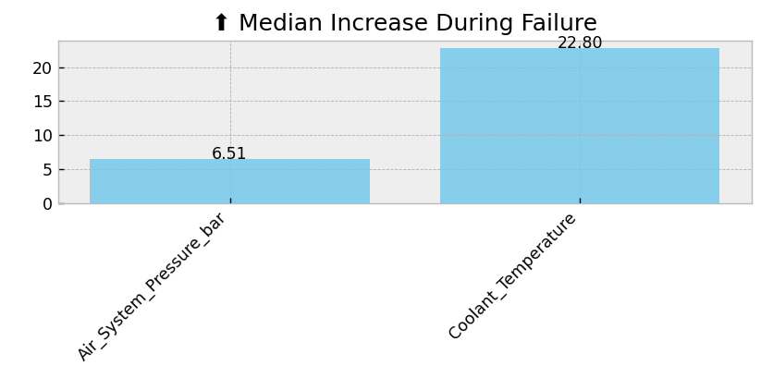

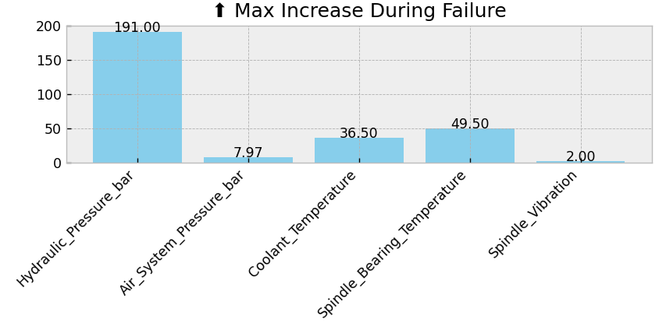

* **Consistently Decreased Parameters During Failure:**

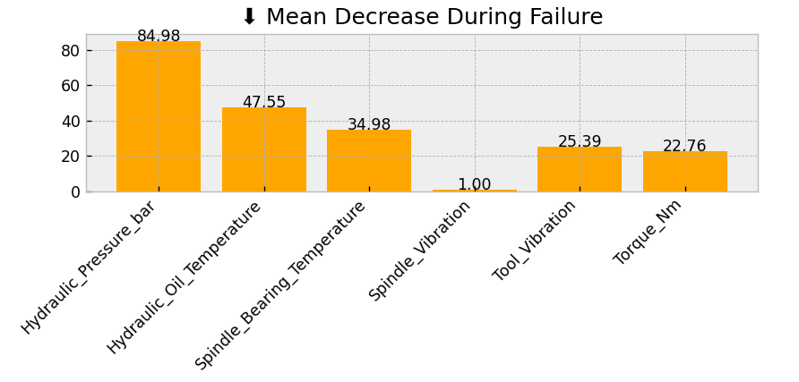

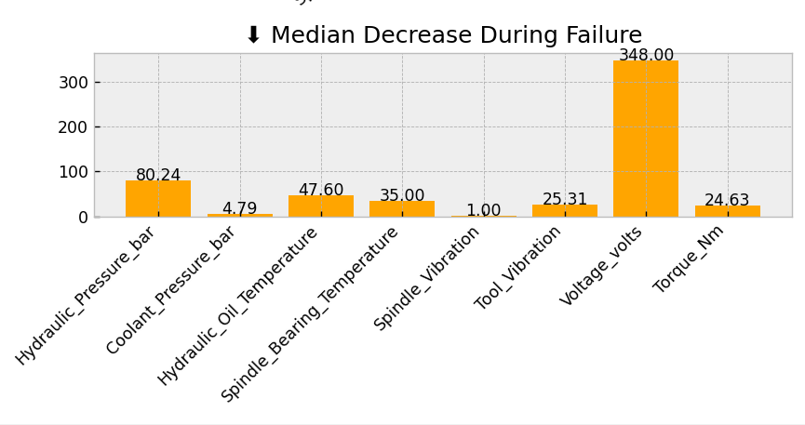

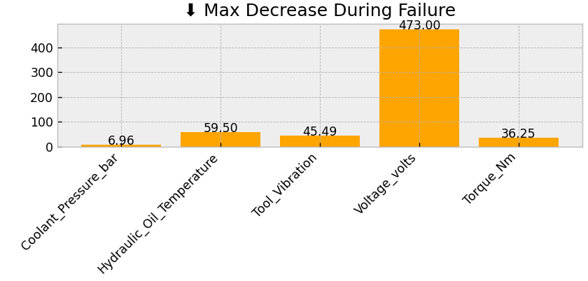

**Spindel Speed Analysis:**

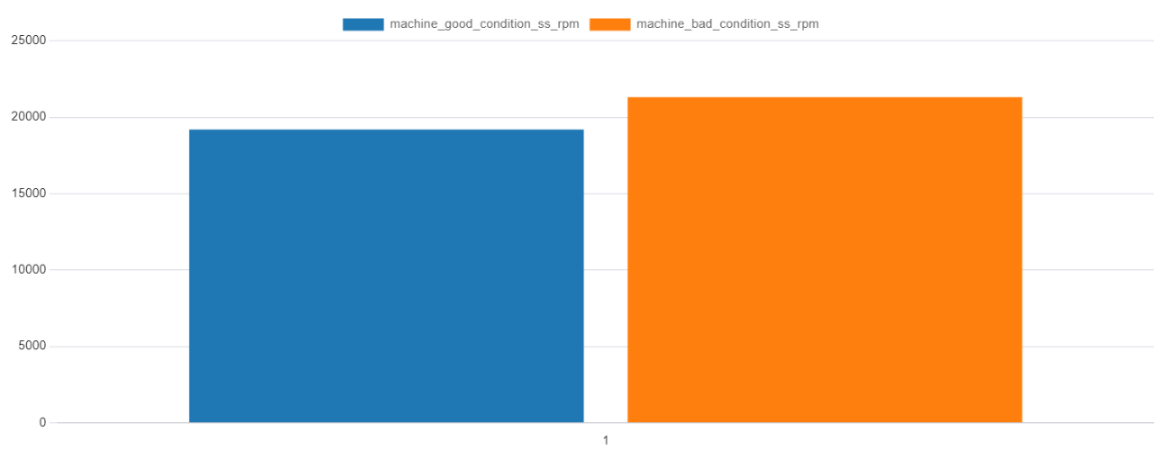

**Conclusion:**

This EDA helps in pinpointing key operational parameters that are directly or inversely associated with machine failure. It empowers decision-makers to:

* Set thresholds for early failure detection
* Optimize parameters to prevent downtime
* Understand underlying patterns within machine behaviour

The use of multiple statistical perspectives (mean, median, max) enriches the insight and supports robust business decision-making in predictive maintenance and manufacturing optimization.